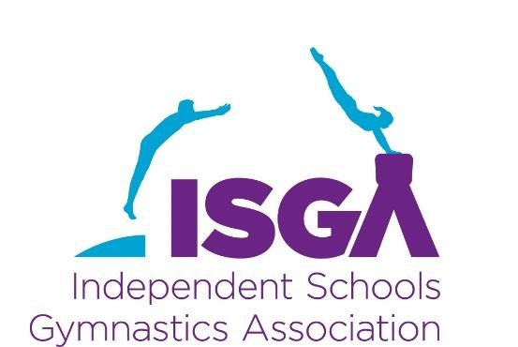

Competition Calendar for
2022 – 2023

Date | Championships | Venue | Host
Sunday  13 November  2022 | ISGA 2 Piece National Championships  (and 5 Piece Qualification competition)  All age groups  Entry Deadline: Tuesday 11 October | St Catherine’s School,  Station Road, Bramley, Guildford, GU5 0DF | Mrs Nancy Moore
Sunday  26 February  2023 | ISGA Boys 4 Piece Premier National Championship  Entry Deadline: Sunday 20 November | Tormead School, Cranley Road, Guildford, Surrey, GU1 2JD | Mr Scott Patterson
Sunday  26 February 2023 | ISGA Girls 4 Piece Challenge Cup National Championships  Entry Deadline: Sunday 20 November | Tormead School, Cranley Road, Guildford, Surrey, GU1 2JD | Mr Scott Patterson
Saturday  25 February  2023 | ISGA Girls 5 Piece Premier  National Championships  For U9 and U15 girls  Entry Deadline: Tuesday 11 October | Tormead School, Cranley Road, Guildford, Surrey, GU1 2JD | Mr Scott Patterson
Saturday  4 March  2023 | ISGA Girls 5 Piece Premier  National Championships  For U10 & U13 girls  Entry Deadline: Tuesday 11 October | Haberdashers’ Boys’ School,  Butterfly Lane, Elstree, Radlett, Borehamwood, WD6 3AF | Mrs Linda North  Ms Emily Burman
Sunday  5 March  2023 | ISGA Girls 5 Piece Premier  National Championships  For U11 & O13 girls  Entry Deadline: Tuesday 11 Octoer | Haberdashers’ Boys’ School,  Butterfly Lane, Elstree, Radlett, Borehamwood, WD6 3AF | Mrs Linda North  Ms Emily Burman
Tuesday  25 April 2023  8.30pm | ISGA AGM | Via Zoom | Mrs Suzanne Rimini
.

Other National Independent Schools Competitions (Not ISGA)

Saturday  19 November  2022 | IAPS National Championships  For U9, U10, U11, U13 girls  U9, U11, U13 boys  Entry deadline: Friday 21 October 2022 at 17:00 | Kent College Pembury,  Old Church Road, Pembury  Tunbridge Wells, Kent, TN2 4AX | Mrs Joanne Cox  Mrs Linda North
Sunday  14 May  2023 | ISA National Championships  For U9 and U11 Girls & Boys  Entries open: Monday 16 January 2023 | Adcote School,  Little Ness, Shrewsbury, Shropshire, SY4 2JY | Miss Louise Hudson  Mrs Paula Curtis-Cole

We will be re-arranging the Judging workshop which was scheduled for September 2022
Member schools will be emailed as soon as we have a new date

October 2022

